# **Using the Public Drive**

What does this mean?

Whenever you want to save a document, or open a document created by someone in the company, we want you to navigate to the folders on the company server.

We have set up **Drive P** as the location where all company files can be located. Once you move to that drive, you will see folders for each department. Only those employees working in the noted department have access to files for that department. Therefore, if you work in the Toronto office, you can access all files for the Toronto office but no other office.

The only exception to this is the General folder where all common files such as vacation forms, expense reports, or the employee handbook are stored. Anyone in the company can access these files.

The following will guide you through the steps to save and/or open files in your department folder. We will use the Seattle office as our demonstration. You need only replace Seattle with your branch location.

## **Saving a File**

When you create a new document and fill it with text you want to save, follow these steps:

1. In the Office program you are using, click File and on the panel at the left, click Save As.

2. Click **More options** (below the Save as type field).

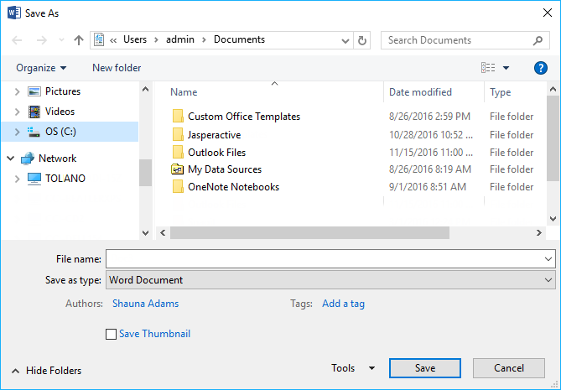

3. In the left panel, click **Network** to display the subsequent folders, as necessary.

4. Click **TOLANO** to display the contents of our server.

5. Click your department folder and then your folder name.

Everyone at Tolano has a folder in their name. You can choose to save the file in the main folder or your department or within your own folder. We recommend your own folder so you can access this file quickly instead of searching the file in the main area.

6. Type the name you want to apply to your new file and then click **Save** (or press ENTER).

The file is now saved in your folder.

## **Opening a File**

Whether you want to open a file you created or someone else created, the process to find and open the file will be the same. What is different is where you need to navigate to find the file so you can open it. For instance, in the previous step, we demonstrated how to save a file into your own folder. If the file you want to open is in Toby’s folder, you will not be able to access that file as Toby is in the Toronto office.

The only way you could get a copy of this file to save is if Toby sends it to you via email or makes a copy of the file in the Seattle folder.

To open a file from the public drive:

1. In the Office program you are using, click **File** and then click **Open**.

2. Click **Browse**.

3. In the panel at the left, click **TOLANO** and then in the panel on the right, click your office location.

4. When you see your folder, double-click the folder to display its contents.

5. **Double-click** the file you want to open.

The document should now appear on the screen, ready for you to view or make changes.